Project Design Phase-II
Data Flow Diagram & User Stories – AI StudyBuddy

Date | 22 September 2026
Team ID | SWTID-2026-2773
Project Name | AI StudyBuddy
Maximum Marks | 4 Marks
- Data Flow Diagrams (DFD
A Data Flow Diagram (DFD) is a visual representation of the information flows within a system. It depicts how data enters and leaves the system, what changes the information, and where data is stored.
Example:(simliped)
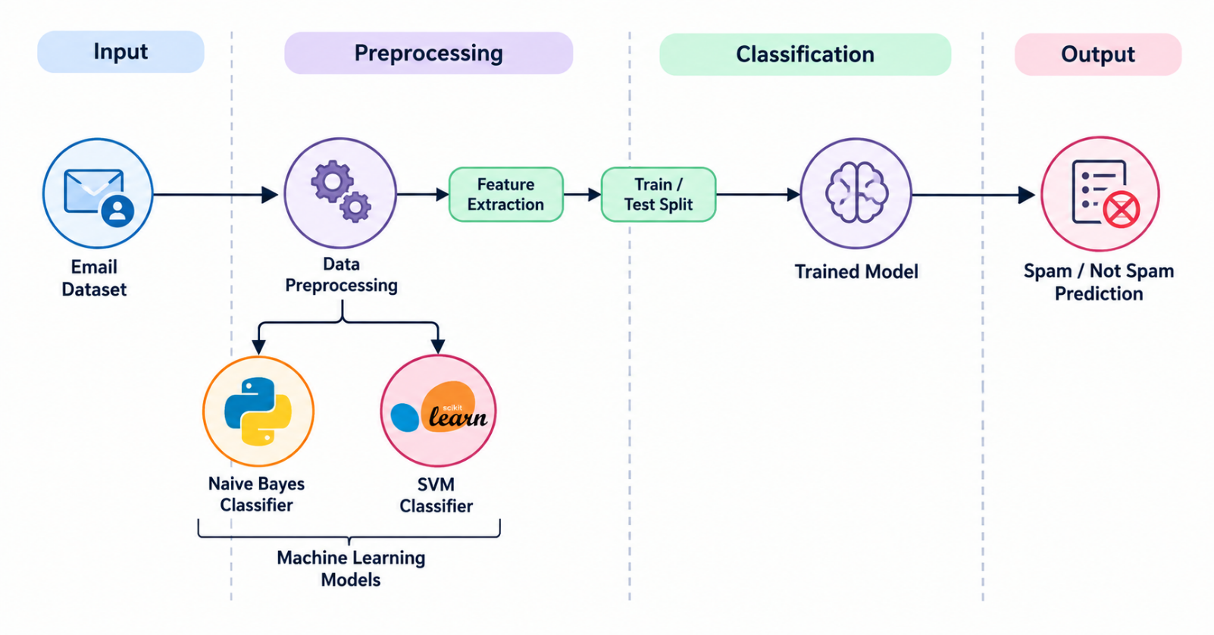

Data Flow Mapping Table
Source / Entity | Process / Flow | Destination / Data Store
Student / Admin | $→$Requests Authentication & Management | Express REST API  DOCX
Express REST API | $↔$Store & Retrieve Users & Materials | MongoDB (Users & Materials)  DOCX
Student | $→$Uploads .txt / .md / .pdf Files | Express REST API  DOCX
AI Controllers | $→$Generates Content Requests | Gemini 2.5 Flash  DOCX
Express REST API | $→$Returns Output to Student | Summary / Flashcards / Quiz / Study Plan  DOCX
Process Execution Steps
- User Configuration & Authentication: Student/Admin registers or logs in via the application and sends credentials to the Express REST API.
DOCX
- Material Upload & Storage: User selects and uploads .txt, .md, or .pdf study materials which are processed by the API and stored in MongoDB.
DOCX
- Text Processing & AI Request: Extracted content from uploaded materials is sent through AI Controllers to Gemini 2.5 Flash.
DOCX
- AI Processing & Enrichment: Gemini 2.5 Flash processes the text and generates automated summaries, dynamic flashcards, MCQ quizzes, or customized study plans.
DOCX
- Data Delivery & Storage: Generated learning materials are returned to the user via the REST API and stored in MongoDB for future reference.
DOCX
2. User Stories
User Type | Functional Requirement (Epic) | User Story Number | User Story / Task | Acceptance Criteria | Priority | Release
Student | Authentication | USN-1 | As a student, I can register with my name, email and password. | User is created and tokens are returned | High | Sprint-1
Student | Authentication | USN-2 | As a student, I can log in with valid credentials. | Valid tokens are returned | High | Sprint-1
Student | Materials | USN-3 | As a student, I can upload study material. | Material is stored successfully | High | Sprint-1
Student | Materials | USN-4 | As a student, I can view and delete my own materials. | Authorized access is enforced | High | Sprint-2
Student | AI Learning | USN-5 | As a student, I can generate a summary. | AI summary is returned and stored | High | Sprint-2
Student | AI Learning | USN-6 | As a student, I can generate flashcards. | Requested flashcards are returned | High | Sprint-2
Student | AI Learning | USN-7 | As a student, I can generate an MCQ quiz. | Quiz with options and answer is returned | High | Sprint-3
Student | AI Learning | USN-8 | As a student, I can generate a study plan. | Day-by-day plan is returned | High | Sprint-3
Administrator | Admin | USN-9 | As an admin, I can view users and statistics. | Admin-only data is returned | Medium | Sprint-3

